**Programming**

**Additional array exercises – Write the following programs**

1. Write a program which declares the following array:

Numbers s

And then write separate pieces of code to:

* Determine how many even numbers are in the array
* The average of the array values
* The median value
* How many numbers in the array are larger than a number entered by a user.

1. Write a program which allows the user to enter **eight** 5-character strings and store them in an array called strArray1 and display its contents.

Using separate pieces of code the program should then determine if:

* Any of the user-entered strings contains “xyz”.
* How many of the user entered string starts with either a “w” or a “g”

The program should then declare a 4-element string array, strArray2. Each element in this array should contain the elements in strArray1 joined together. So element 0 and 1 of strArray1 should be joined together to make element 0 of strArray2, elements 2 and 3 of strArray1 should be joined together to make element 1 of strArray2 and so on as follows:

strArray1

|  |  |  |  |  |  |  |  |
| --- | --- | --- | --- | --- | --- | --- | --- |
| ghfry | rtysc | uiswe | qwsnp | aloxn | nhtys | lksdb | zxbyj |

strArray2

|  |  |  |  |
| --- | --- | --- | --- |
| ghfryrtysc | uisweqwsnp | aloxnnhtys | lksdbzxbyj |

* The program should then display how many times a user-entered character appears in strArray2 e.g.

***Please enter a character:*** *x*

*X appears 2 times in the array*

1. Write a program using arrays to do the following:

* Ask for 5 users names
* Simulate the throwing of two dice and add the scores from each die
* Store the users scores in a separate array
* Display a message showing the name of the users who user scored a 7 or 11 together with a message saying “you have won the jackpot!”.

**Sample Ouput**

**Question 1:**

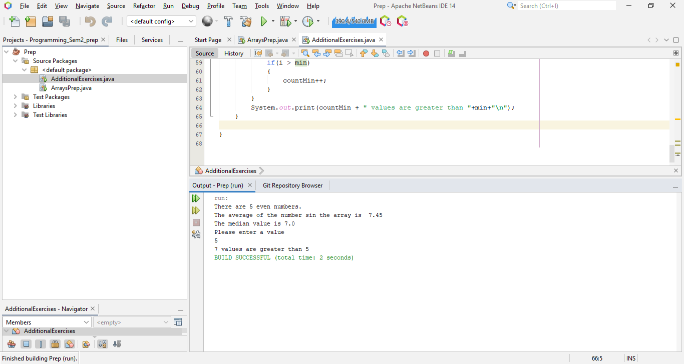

**Question 2:**

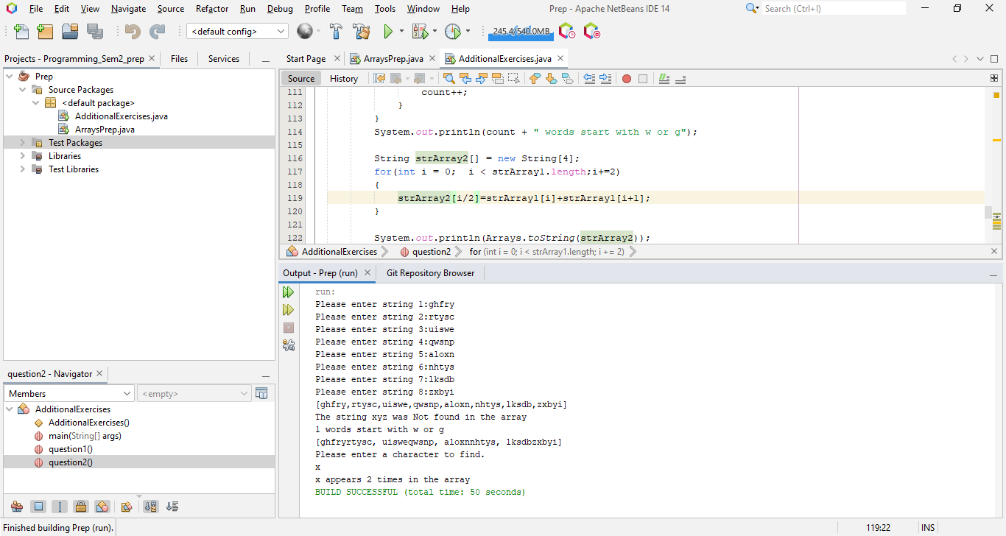

**Question 3:**

